City of Bastrop Inspection Requirements

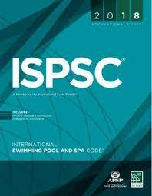

International Swimming Pool and Spa Code (ISPSC)

106.2 Preliminary inspection
Before issuing a permit, the code official is authorized to examine or cause to be examined buildings, structures and sites.
106.3 Required inspections and testing
All aquatic vessel installations or alterations thereto, including equipment, piping, and related appliances shall be inspected to ensure compliance.
106.4 Other inspections
The code official is authorized to make or require other inspections of any construction work to ascertain compliance

City of Bastrop Inspections
- Pool Layout
- Pool Bonding
- Pool Pre-Pour
- Pool Gas Line
- CSI Inspection
- Pool Final

